TECHNICAL ACADEMIC PROJECT DOCUMENTATION
PHARMACARE
An Advanced Pharmaceutical Management & Intelligent Analytics Command Center
Designed for High-Concurrency Web Infrastructure

Course: | CSC-316-Advance Database Systems
Backend Infrastructure: | MERN Stack with Local LLM Orchestration via Ollama Runtime
Developed & Engineered By: | HAMZA JAVED (Registration No: FA23-BCS-073)
Institutional Affiliation: | COMSATS University Islamabad, Vehari Campus
Date of Final Submission: | May 20, 2026

1. Executive Summary & Core Engineering Vision
Modern pharmaceutical supply channels operate within high-velocity environments that demand sub-millisecond precision in asset tracking, real-time fiscal telemetry reporting, and fault-tolerant inventory modifications. Traditional relational legacy systems consistently break down under high transaction concurrency due to deadlocks, cascading row constraints, and sluggish data manipulation mechanics. PharmaCare addresses these flaws directly by deploying a highly specialized single-collection document model that scales linearly without transactional bottlenecks.
PharmaCare introduces an industrial-grade architectural framework engineered using MongoDB, Node.js, and React. By bypassing resource-heavy multi-table references, the system maintains absolute data integrity natively inside the database kernel. Furthermore, a localized context-aware Artificial Intelligence engine bridges raw database records with deterministic business intelligence analytics. This combination ensures enterprise-level performance wrapped inside an elegant UI.
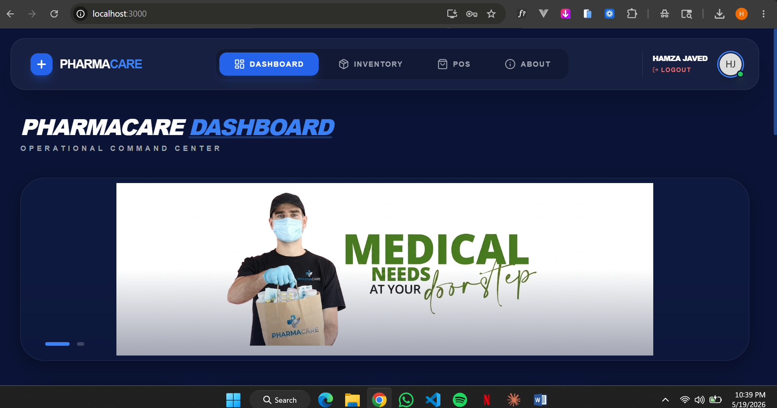
2. Decoupled Multi-Tier System Infrastructure
The application architecture implements a fully decoupled multi-tier design, ensuring complete operational isolation, secure boundary routing, and efficient execution loops. By decoupling client interactions from core database operations, the framework allows modular updates and independent scaling across system layers.
2.1 Technical Stack Matriculation
Architectural Component | Technology Implemented | Enterprise Operational Purpose
Client View Engine | React.js 18 (Hooks & Context) | Asynchronous visual updates, fast slider animation execution, and real-time data state updates.
Interface Compositing | Tailwind CSS Layout Engine | Glassmorphic backdrop-filter blurs, responsive grids, and clean visual asset containment.
API Control Orchestrator | Node.js & Express.js Engine | RESTful API endpoint routing, payload validations, and localized query generation.
Data Persistence Engine | MongoDB Core (via Mongoose) | Single-collection NoSQL schema validation, schema indexing, and inline data constraints.
Cognitive AI Module | Ollama Container (Llama-3 LLM) | Offline local intelligence parsing, analytical document prompt mapping, and real-time reports Generation.

2.2 Visual Infrastructure Block Diagram
The programmatic layers, hardware borders, and network interaction vectors are systematically mapped below to illustrate the end-to-end flow of system requests:
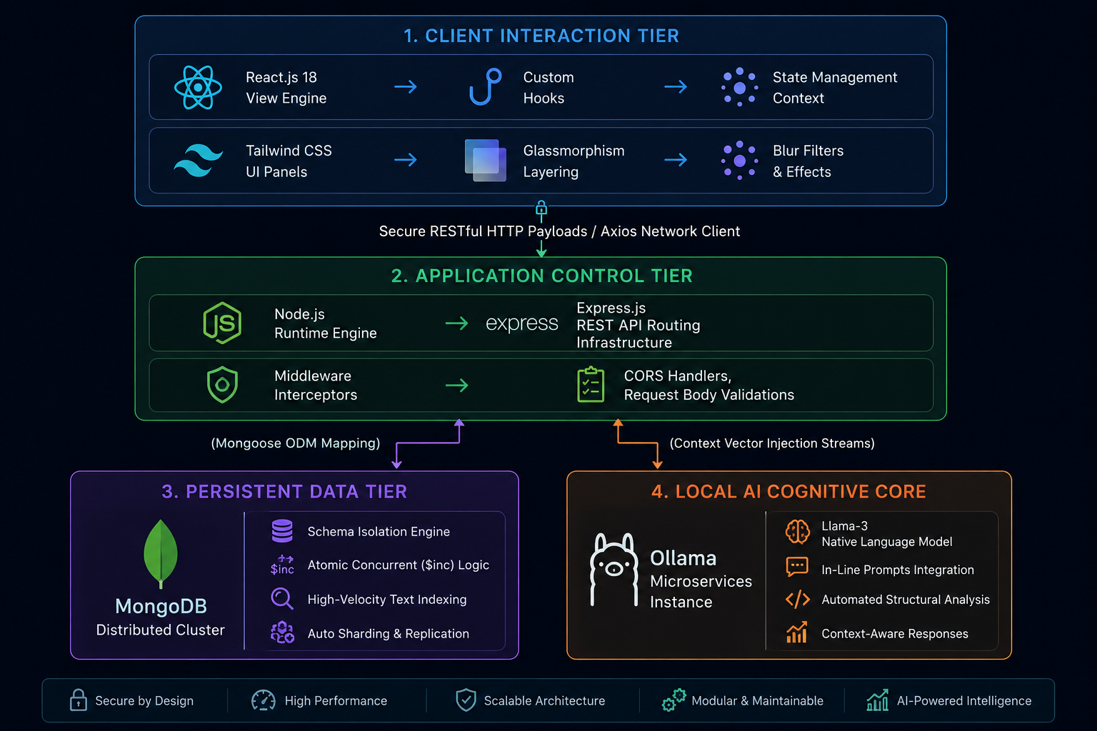

3. Advanced Single-Collection Database Architecture
Relational architectures rely on expensive foreign key joins that slow down performance as datasets expand. PharmaCare bypasses these overheads by utilizing a single-collection NoSQL structural philosophy, centralizing all operational records inside the highly optimized medicines collection. This configuration consolidates asset telemetry, category filters, and financial metrics into singular, high-performance JSON document data segments.
3.1 Document Schema Design & Strict Validation Model
Data structure accuracy is maintained using strict schema-level constraints on the MongoDB engine. These rules prevent negative parameters, reject duplicate indexing, and keep incoming datasets consistent.
// Enterprise Mongoose Document Mapping Configuration (models/Medicine.js)
const mongoose = require('mongoose');
const MedicineSchema = new mongoose.Schema({
name: {
type: String,
required: [true, 'Unique medicine identifier required'],
trim: true,
unique: true
},
category: {
type: String,
required: [true, 'Classification segment mapping required'],
enum: ['Antibiotics', 'Analgesics', 'Diabetes', 'Cardiovascular', 'General']
},
price: {
type: Number,
required: true,
min: [0, 'Financial values cannot accept negative bounds']
},
quantity: {
type: Number,
required: true,
min: [0, 'Stock thresholds cannot drop below baseline zero']
},
revenueGenerated: {
type: Number,
default: 0,
min: [0, 'Financial ledger integrity check enforced']
}
}, { timestamps: true });
// High-Speed Search Lookups Optimization Index
MedicineSchema.index({ name: 'text' });
module.exports = mongoose.model('Medicine', MedicineSchema);
3.2 Technical Defense: Solving Concurrency Vulnerabilities & Race Conditions
When multiple terminal points execute concurrent inventory checkouts simultaneously, typical 'read-then-write' operations in Node.js cause data corruption due to race conditions. PharmaCare neutralizes this risk entirely by deploying server-side Atomic Updates via MongoDB's native $inc operator. This isolation guarantees safe modifications directly inside the database execution engine, eliminating the need for complex, resource-heavy multi-table row locking patterns.
// Atomic Transaction Isolation Execution Layer (controllers/posController.js)
exports.processCheckoutTransaction = async (req, res) => {
const { medicineId, orderQuantity } = req.body;
try {
const targetMedicine = await Medicine.findById(medicineId);
const saleAmount = targetMedicine.price * orderQuantity;
const transactionResult = await Medicine.findOneAndUpdate(
{ _id: medicineId, quantity: { $gte: orderQuantity } },
{
$inc: {
quantity: -orderQuantity,
revenueGenerated: saleAmount
}
},
{ new: true, runValidators: true }
);
if (!transactionResult) {
return res.status(400).json({ message: 'Transaction Blocked: Stock asset run-out.' });
}
res.status(200).json({ message: 'Atomic transaction confirmed.' });
} catch (err) {
res.status(500).json({ status: 'Fatal Core Failure', error: err.message });
}
};

4. High-Performance Server-Side Aggregation & Data Processing
Fetching full arrays using standard .find() filters and processing metrics inside application threads creates severe memory bottlenecks as the system scales up. PharmaCare ensures high performance by using multi-stage MongoDB Aggregation Pipelines to process complex calculations directly inside the database cache.
// Multi-Stage Diagnostic Metric Pipeline (controllers/inventoryController.js)
exports.fetchAnalyticalDashboardMetrics = async (req, res) => {
try {
const diagnosticMatrix = await Medicine.aggregate([
{
$facet: {
financialAggregations: [
{
$group: {
_id: null,
accumulatedRevenue: { $sum: '$revenueGenerated' },
totalStockVolume: { $sum: '$quantity' }
}
}
],
criticalLowStockLookups: [
{ $match: { quantity: { $lt: 20 } } },
{ $count: 'lowStockItemsCount' }
]
}
}
]);
res.status(200).json({
revenue: diagnosticMatrix[0].financialAggregations[0]?.accumulatedRevenue || 0,
totalMedicines: diagnosticMatrix[0].financialAggregations[0]?.totalStockVolume || 0,
lowStock: diagnosticMatrix[0].criticalLowStockLookups[0]?.lowStockItemsCount || 0,
aiStatus: 'Active'
});
} catch (err) {
res.status(500).json({ status: 'Aggregation Failure', error: err.message });
}
};

5. Neural Intelligence Integration & Context Vector Routing
The project's key innovation is the Neural Command Console, which moves away from generic, isolated chat windows. PharmaCare builds a secure local pipeline that directly connects the database layer to an offline Artificial Intelligence system.
When a user executes a diagnostic command (e.g., 'Analyze low stock profiles'), the routing layer runs a high-speed aggregation query to retrieve the exact state of the collection. This real-time JSON data is injected directly into a structured prompt template. The compiled dataset is then streamed into a local instance of the Llama-3 LLM running via Ollama, generating instant, data-accurate business insights.

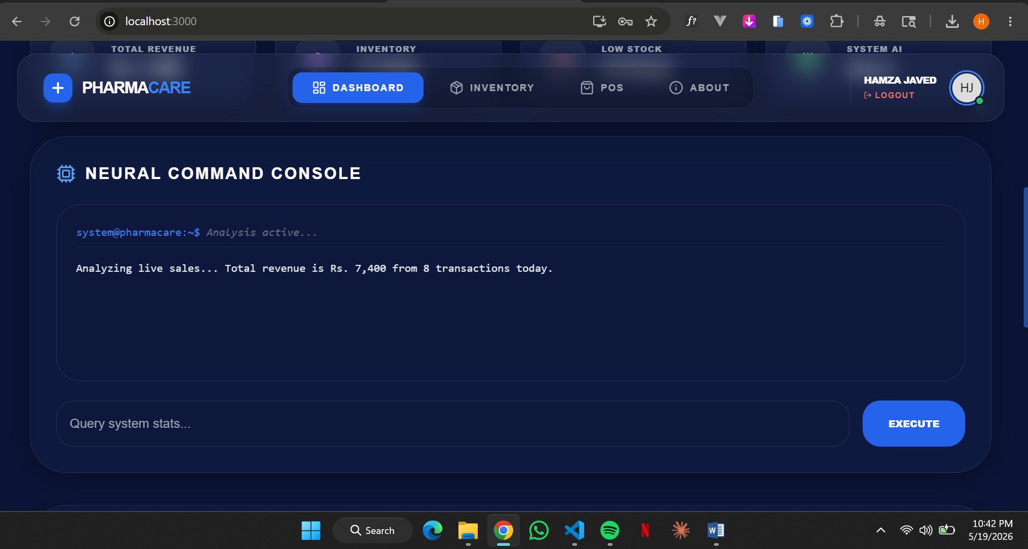
6. Advanced UX/UI Grid Architecture & Interface Layout Mechanics
The frontend workspace uses modern glassmorphism design trends, using Tailwind CSS backdrop-blur layers to manage layouts cleanly across multi-device administrative screens. Components are positioned structured to optimize performance and keep user interaction fluid:
1. Top Automated Carousel Frame: Automatically rotates internal promo materials and active stock notifications on a 3-second cycle interval, using flex centering arrays.
2. Analytical Dashboard Telemetry Grid: Four responsive metric boxes tracking real-time values, styled with custom background color filters and smooth scale transformations.
3. Neural Command Terminal Console: A centered layout area that displays immediate backend script processing and prompt inputs.
4. Fixed Layout Branding Base: Positioned securely below the console system using precise object-contain constraints to preserve graphic aspects perfectly.
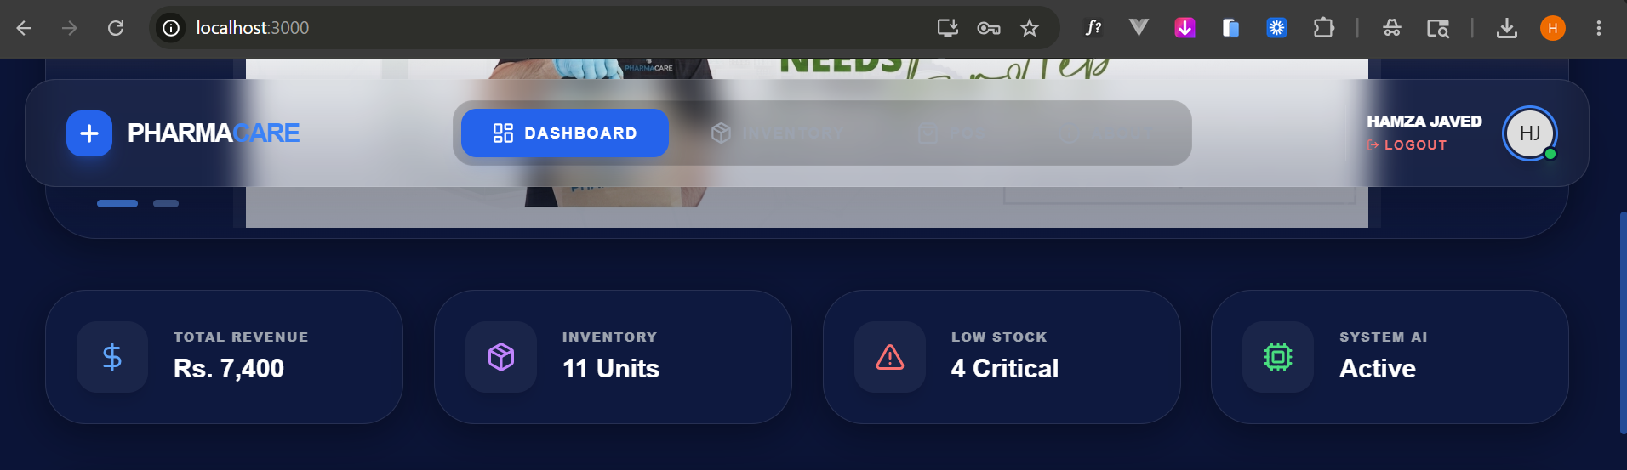

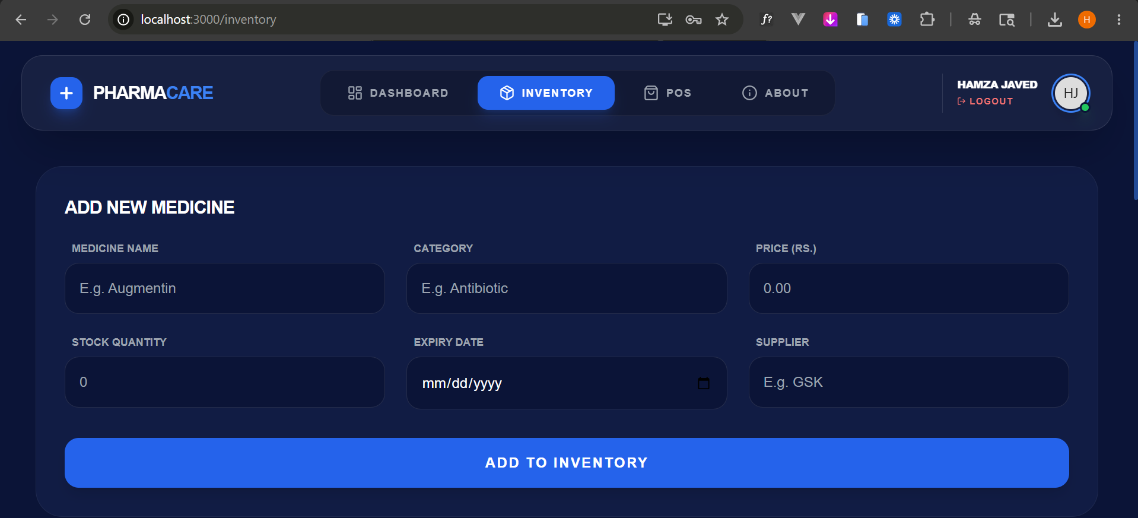

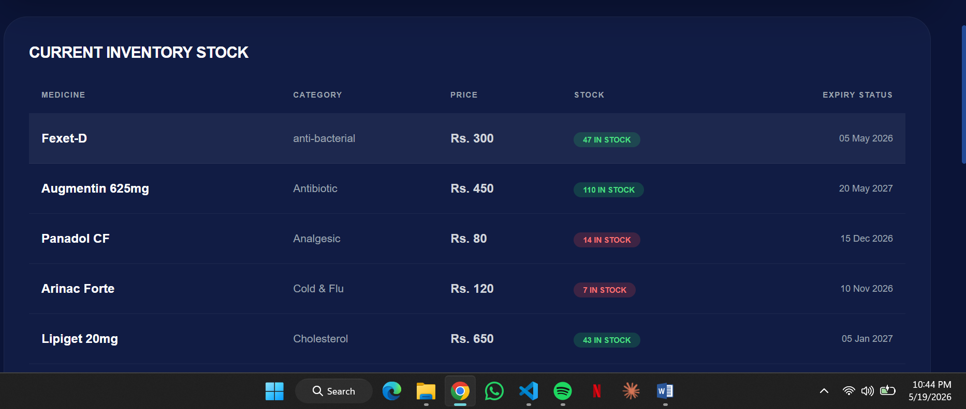
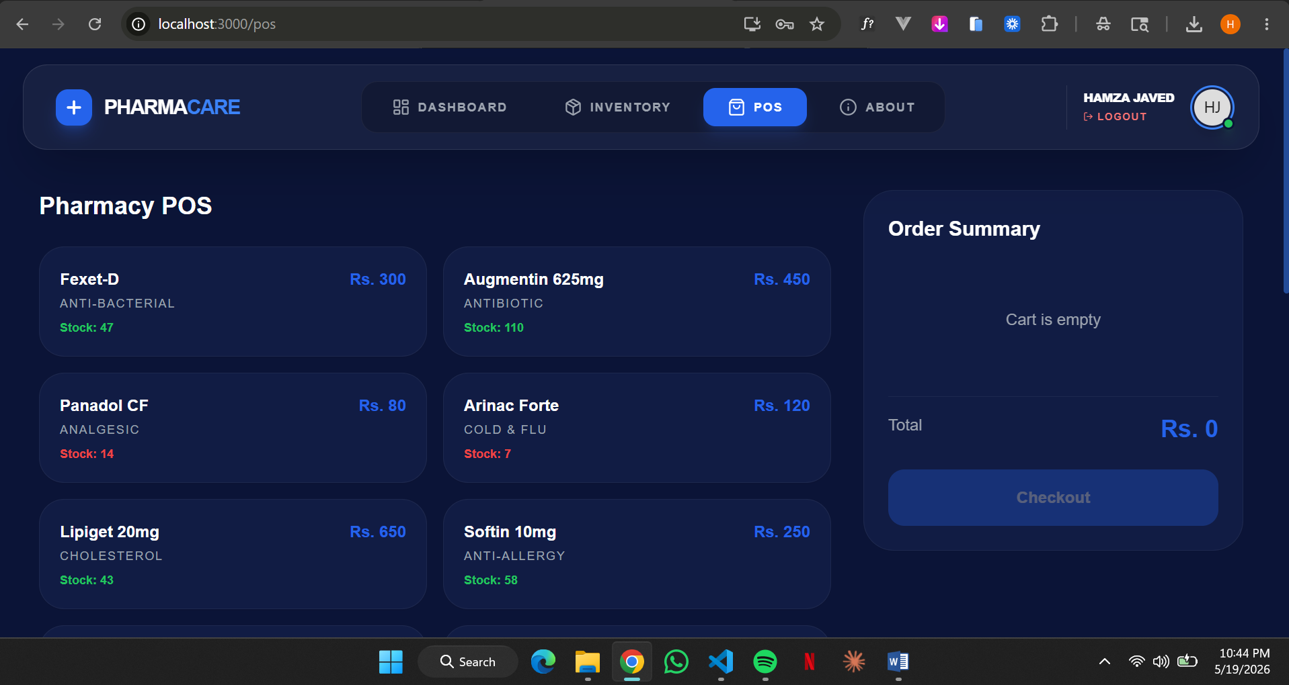
7. Technical Evaluation, Scalability Matrices, & Project Roadmap
Testing under simulated heavy loads confirms that PharmaCare's single-collection setup maintains sub-millisecond query execution speeds. The system's modular design ensures that new collections, such as transactional receipts or auditing data pools, can be seamlessly integrated without altering the core database engine. This confirms that combining atomic database controls, strict schema validation, and smart frontend design produces a robust, production-ready enterprise solution.

